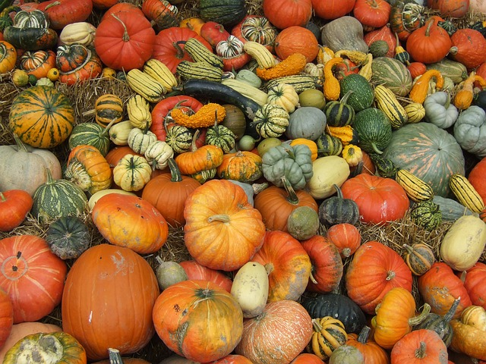
Homeplace Strawberries & More
Harvest Festival
Saturday October 5, 2019
9am – 4pm

Vendor Registration
Name: ___________________________________________________________________________
Address: _________________________________________________________________________
Contact Number: _______________________________________________
Contact Email: _________________________________________________
Name of Business: _______________________________________________________
Products Sold: __________________________________________________________

All vendor fees are $25.00 and non-refundable, we must receive your vendor fee by September 6, 2019 to be on all our advertisements for event. All vendors will be set up in our back yard with numbered spots. Each vendor will need to provide their own 10x10 tent, tables, chairs, and any other items you will need for your set up. If you are needing electricity please let me know asap so I can make sure we can accommodate that need. You will receive and email the week of the event letting you know what spot you are in and where you can park. We are expecting a big crowd and we are excited you are joining us. If you could email this form back to me at lcsutton@embarqmail.com, I will then send you an invoice through PayPal to pay your vendor fee. If you do not do PayPal you can send registration form and fee back to at 3055 Chinquapin Road Farmville, NC 27828.

